Week 1 Task: Data Cleaning and Preliminary Analysis with R
Dataset: Titanic Passenger Data (891 passengers, 12 variables)
[Praloy Sardar] | [Virtual R Data Analyst Intern/ Yuvaintern] | [04/10/2026]
Table of Contents
1. Objective and Dataset Overview 2
1.1 Why this dataset? 2
1.2 Data dictionary 2
1.3 Loading the data 3
2. Initial Inspection 3
2.1 Duplicate check 4
3. Data Cleaning Process 5
3.1 Missing value audit 5
3.2 Feature extraction: Title 6
3.3 Imputing Age 7
3.4 Imputing Embarked and handling Cabin 8
3.5 Type conversion and derived features 9
3.6 Outlier detection 10
3.7 Normalisation 12
3.8 Encoding categorical variables 13
3.9 Saving the cleaned dataset 14
4. Exploratory Data Analysis 14
4.1 Descriptive statistics 14
4.2 Survival by key categorical variables 15
4.3 Survival by age 16
4.4 Fare and family size 18
4.5 Correlation analysis 19
5. Summary of Insights 21
6. Limitations and Next Steps 21
Appendix: Session Information 21

1. Objective and Dataset Overview
The objective of this task is to take a raw, publicly available dataset through a complete data cleaning and preliminary analysis workflow in R: inspecting structure, handling missing values, detecting outliers, normalising numeric variables, encoding categorical variables, and carrying out exploratory data analysis (EDA).

1.1 Why this dataset?
The Titanic passenger dataset (Data Science Dojo public repository, derived from the Kaggle “Titanic: Machine Learning from Disaster” data) was chosen because it satisfies the brief’s requirements for a messy, realistic dataset:
- Missing values in several columns at very different severities (Age ~20%, Cabin ~77%, Embarked <1%), which forces different handling strategies rather than one blanket rule.
- A mix of numeric and categorical variables (continuous Age and Fare, discrete counts, nominal Sex and Embarked, ordinal Pclass, and free text in Name).
- Skewed numeric data with outliers (Fare has an extreme right tail).
- A clear analytical question (which factors are associated with survival?), so the cleaning decisions can be judged by whether they preserve useful signal.
A known limitation is that the dataset is small (891 rows) and historical, so the findings are descriptive and should not be generalised.

1.2 Data dictionary
Variable | Type | Description
PassengerId | integer | Unique row identifier
Survived | integer (0/1) | Survival outcome (target variable)
Pclass | integer (1/2/3) | Ticket class: a proxy for socio-economic status
Name | text | Passenger name (contains a title such as Mr, Mrs, Miss)
Sex | categorical | male / female
Age | numeric | Age in years
SibSp | integer | Number of siblings or spouses aboard
Parch | integer | Number of parents or children aboard
Ticket | text | Ticket number
Fare | numeric | Passenger fare
Cabin | text | Cabin number
Embarked | categorical | Port of embarkation (C = Cherbourg, Q = Queenstown, S = Southampton)

1.3 Loading the data
raw <- read.csv("titanic.csv", stringsAsFactors = FALSE, na.strings = c("", "NA"))
Note the na.strings = c("", "NA") argument. In this file, missing values are stored as empty strings, which R would otherwise read as a valid (blank) category. Declaring them as NA at import time is the first cleaning step.

2. Initial Inspection
dim(raw)
#> [1] 891 12
str(raw)
#> 'data.frame': 891 obs. of 12 variables:
#> $ PassengerId: int 1 2 3 4 5 6 7 8 9 10 ...
#> $ Survived : int 0 1 1 1 0 0 0 0 1 1 ...
#> $ Pclass : int 3 1 3 1 3 3 1 3 3 2 ...
#> $ Name : chr "Braund, Mr. Owen Harris" "Cumings, Mrs. John Bradley (Florence Briggs Thayer)" "Heikkinen, Miss. Laina" "Futrelle, Mrs. Jacques Heath (Lily May Peel)" ...
#> $ Sex : chr "male" "female" "female" "female" ...
#> $ Age : num 22 38 26 35 35 NA 54 2 27 14 ...
#> $ SibSp : int 1 1 0 1 0 0 0 3 0 1 ...
#> $ Parch : int 0 0 0 0 0 0 0 1 2 0 ...
#> $ Ticket : chr "A/5 21171" "PC 17599" "STON/O2. 3101282" "113803" ...
#> $ Fare : num 7.25 71.28 7.92 53.1 8.05 ...
#> $ Cabin : chr NA "C85" NA "C123" ...
#> $ Embarked : chr "S" "C" "S" "S" ...
head(raw, 5)
#> PassengerId Survived Pclass
#> 1 1 0 3
#> 2 2 1 1
#> 3 3 1 3
#> 4 4 1 1
#> 5 5 0 3
#> Name Sex Age SibSp Parch
#> 1 Braund, Mr. Owen Harris male 22 1 0
#> 2 Cumings, Mrs. John Bradley (Florence Briggs Thayer) female 38 1 0
#> 3 Heikkinen, Miss. Laina female 26 0 0
#> 4 Futrelle, Mrs. Jacques Heath (Lily May Peel) female 35 1 0
#> 5 Allen, Mr. William Henry male 35 0 0
#> Ticket Fare Cabin Embarked
#> 1 A/5 21171 7.2500 <NA> S
#> 2 PC 17599 71.2833 C85 C
#> 3 STON/O2. 3101282 7.9250 <NA> S
#> 4 113803 53.1000 C123 S
#> 5 373450 8.0500 <NA> S
summary(raw)
#> PassengerId Survived Pclass Name
#> Min. : 1.0 Min. :0.0000 Min. :1.000 Length:891
#> 1st Qu.:223.5 1st Qu.:0.0000 1st Qu.:2.000 Class :character
#> Median :446.0 Median :0.0000 Median :3.000 Mode :character
#> Mean :446.0 Mean :0.3838 Mean :2.309
#> 3rd Qu.:668.5 3rd Qu.:1.0000 3rd Qu.:3.000
#> Max. :891.0 Max. :1.0000 Max. :3.000
#>
#> Sex Age SibSp Parch
#> Length:891 Min. : 0.42 Min. :0.000 Min. :0.0000
#> Class :character 1st Qu.:20.12 1st Qu.:0.000 1st Qu.:0.0000
#> Mode :character Median :28.00 Median :0.000 Median :0.0000
#> Mean :29.70 Mean :0.523 Mean :0.3816
#> 3rd Qu.:38.00 3rd Qu.:1.000 3rd Qu.:0.0000
#> Max. :80.00 Max. :8.000 Max. :6.0000
#> NA's :177
#> Ticket Fare Cabin Embarked
#> Length:891 Min. : 0.00 Length:891 Length:891
#> Class :character 1st Qu.: 7.91 Class :character Class :character
#> Mode :character Median : 14.45 Mode :character Mode :character
#> Mean : 32.20
#> 3rd Qu.: 31.00
#> Max. :512.33
#>
Observations from the raw data
- 891 rows and 12 columns. Survived, Pclass, Sex and Embarked are stored as integers or text but are really categorical, so they need type conversion.
- Age has missing values, and Fare has a maximum (512.33) far above its median (14.45), which signals a heavy right skew.
- Name, Ticket and Cabin are free text and cannot be used directly in numeric analysis.

2.1 Duplicate check
sum(duplicated(raw))
#> [1] 0
sum(duplicated(raw$PassengerId))
#> [1] 0
There are no duplicate rows and no duplicate passenger IDs, so no records need to be removed.

3. Data Cleaning Process
All cleaning is applied to a copy (df) so that the raw data remains untouched and the process is reproducible.

3.1 Missing value audit
missing_tbl <- data.frame(
variable = names(raw),
n_missing = colSums(is.na(raw)),
pct = round(100 * colMeans(is.na(raw)), 1),
row.names = NULL
) %>% arrange(desc(n_missing))
missing_tbl
#> variable n_missing pct
#> 1 Cabin 687 77.1
#> 2 Age 177 19.9
#> 3 Embarked 2 0.2
#> 4 PassengerId 0 0.0
#> 5 Survived 0 0.0
#> 6 Pclass 0 0.0
#> 7 Name 0 0.0
#> 8 Sex 0 0.0
#> 9 SibSp 0 0.0
#> 10 Parch 0 0.0
#> 11 Ticket 0 0.0
#> 12 Fare 0 0.0
missing_tbl %>%
filter(n_missing > 0) %>%
ggplot(aes(x = reorder(variable, pct), y = pct)) +
geom_col(fill = "#2c7fb8") +
geom_text(aes(label = paste0(pct, "%")), hjust = -0.1, size = 3.5) +
coord_flip() + ylim(0, 90) +
labs(x = NULL, y = "% missing")
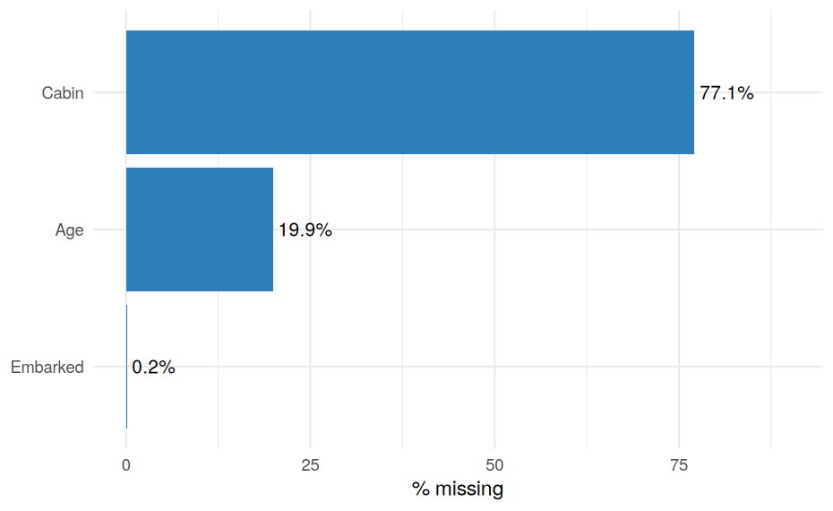
Figure 1: Percentage of missing values by variable (raw data).
Handling strategy. Each variable gets a method matched to how much is missing and how much it matters:
Variable | Missing | Decision | Rationale
Cabin | 77.1% | Do not impute; create HasCabin flag and extract Deck | Imputing three quarters of a column would fabricate data. But the fact that a cabin was recorded is informative (it is correlated with class).
Age | 19.9% | Impute with the group median by Title and Pclass | Too much to drop (loses 177 rows) and the overall median would blur real age differences, for example “Master” (boys) versus “Mr”.
Embarked | 0.2% (2 rows) | Impute with the mode | Only two values; the mode is a low-risk choice.

3.2 Feature extraction: Title
Titles embedded in Name are a strong age proxy, so they are extracted first and used to drive the Age imputation.
df <- raw
df$Title <- sub("^.*, (.*?)\\..*$", "\\1", df$Name)
table(df$Title)
#>
#> Capt Col Don Dr Jonkheer Lady
#> 1 2 1 7 1 1
#> Major Master Miss Mlle Mme Mr
#> 2 40 182 2 1 517
#> Mrs Ms Rev Sir the Countess
#> 125 1 6 1 1
# Collapse rare titles into broader groups
df$Title <- case_when(
df$Title %in% c("Mlle", "Ms") ~ "Miss",
df$Title %in% c("Mme") ~ "Mrs",
df$Title %in% c("Mr", "Mrs", "Miss", "Master") ~ df$Title,
TRUE ~ "Rare"
)
table(df$Title)
#>
#> Master Miss Mr Mrs Rare
#> 40 185 517 126 23

3.3 Imputing Age
age_before <- df$Age # keep a copy to compare distributions afterwards
overall_median <- median(df$Age, na.rm = TRUE)
df <- df %>%
group_by(Title, Pclass) %>%
mutate(Age = ifelse(is.na(Age),
median(Age, na.rm = TRUE),
Age)) %>%
ungroup()
# Safety net: any group that was entirely NA falls back to the overall median
df$Age[is.na(df$Age)] <- overall_median
sum(is.na(df$Age))
#> [1] 0
To check that imputation did not distort the data, the distribution before and after is compared:
bind_rows(
data.frame(Age = age_before[!is.na(age_before)], stage = "Before (observed only)"),
data.frame(Age = df$Age, stage = "After imputation")
) %>%
ggplot(aes(Age, fill = stage)) +
geom_histogram(binwidth = 4, colour = "white") +
facet_wrap(~stage, ncol = 1) +
scale_fill_manual(values = c("#2c7fb8", "#7fcdbb"), guide = "none") +
labs(y = "Count")
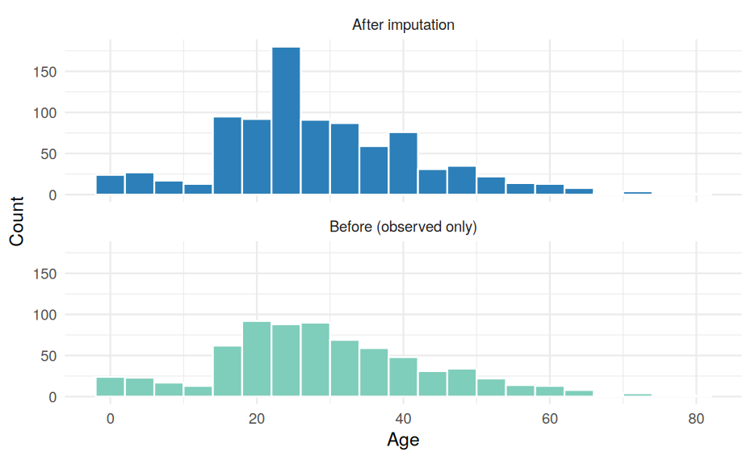
Figure 2: Age distribution before (observed values only) and after imputation.
c(mean_before = mean(age_before, na.rm = TRUE), mean_after = mean(df$Age),
sd_before = sd(age_before, na.rm = TRUE), sd_after = sd(df$Age))
#> mean_before mean_after sd_before sd_after
#> 29.69912 29.13543 14.52650 13.49088
The mean is almost unchanged, while the standard deviation shrinks slightly. That is the expected side effect of any median imputation (it adds values at the centre), and it is worth remembering when interpreting variance-based statistics later.

3.4 Imputing Embarked and handling Cabin
# Embarked: mode imputation
embarked_mode <- names(which.max(table(df$Embarked)))
embarked_mode
#> [1] "S"
df$Embarked[is.na(df$Embarked)] <- embarked_mode
# Cabin: convert missingness into information, then drop the raw column
df$HasCabin <- as.integer(!is.na(df$Cabin))
df$Deck <- ifelse(is.na(df$Cabin), "Unknown", substr(df$Cabin, 1, 1))
df$Cabin <- NULL
colSums(is.na(df))
#> PassengerId Survived Pclass Name Sex Age
#> 0 0 0 0 0 0
#> SibSp Parch Ticket Fare Embarked Title
#> 0 0 0 0 0 0
#> HasCabin Deck
#> 0 0
No missing values remain.

3.5 Type conversion and derived features
df$Survived <- factor(df$Survived, levels = c(0, 1), labels = c("No", "Yes"))
df$Pclass <- factor(df$Pclass, levels = c(1, 2, 3), ordered = TRUE)
df$Sex <- factor(df$Sex)
df$Embarked <- factor(df$Embarked)
df$Title <- factor(df$Title)
df$Deck <- factor(df$Deck)
# Family size = siblings/spouses + parents/children + the passenger themself
df$FamilySize <- df$SibSp + df$Parch + 1
str(df)
#> tibble [891 x 15] (S3: tbl_df/tbl/data.frame)
#> $ PassengerId: int [1:891] 1 2 3 4 5 6 7 8 9 10 ...
#> $ Survived : Factor w/ 2 levels "No","Yes": 1 2 2 2 1 1 1 1 2 2 ...
#> $ Pclass : Ord.factor w/ 3 levels "1"<"2"<"3": 3 1 3 1 3 3 1 3 3 2 ...
#> $ Name : chr [1:891] "Braund, Mr. Owen Harris" "Cumings, Mrs. John Bradley (Florence Briggs Thayer)" "Heikkinen, Miss. Laina" "Futrelle, Mrs. Jacques Heath (Lily May Peel)" ...
#> $ Sex : Factor w/ 2 levels "female","male": 2 1 1 1 2 2 2 2 1 1 ...
#> $ Age : num [1:891] 22 38 26 35 35 26 54 2 27 14 ...
#> $ SibSp : int [1:891] 1 1 0 1 0 0 0 3 0 1 ...
#> $ Parch : int [1:891] 0 0 0 0 0 0 0 1 2 0 ...
#> $ Ticket : chr [1:891] "A/5 21171" "PC 17599" "STON/O2. 3101282" "113803" ...
#> $ Fare : num [1:891] 7.25 71.28 7.92 53.1 8.05 ...
#> $ Embarked : Factor w/ 3 levels "C","Q","S": 3 1 3 3 3 2 3 3 3 1 ...
#> $ Title : Factor w/ 5 levels "Master","Miss",..: 3 4 2 4 3 3 3 1 4 4 ...
#> $ HasCabin : int [1:891] 0 1 0 1 0 0 1 0 0 0 ...
#> $ Deck : Factor w/ 9 levels "A","B","C","D",..: 9 3 9 3 9 9 5 9 9 9 ...
#> $ FamilySize : num [1:891] 2 2 1 2 1 1 1 5 3 2 ...

3.6 Outlier detection
Outliers are examined in the continuous variables Age and Fare using the IQR rule (values beyond 1.5 x IQR from the quartiles) and visually with boxplots.
iqr_bounds <- function(x) {
q <- quantile(x, c(.25, .75))
i <- q[2] - q[1]
c(lower = unname(q[1] - 1.5 * i), upper = unname(q[2] + 1.5 * i))
}
b_age <- iqr_bounds(df$Age)
b_fare <- iqr_bounds(df$Fare)
rbind(Age = b_age, Fare = b_fare)
#> lower upper
#> Age -2.625 60.3750
#> Fare -26.724 65.6344
c(age_outliers = sum(df$Age < b_age["lower"] | df$Age > b_age["upper"]),
fare_outliers = sum(df$Fare < b_fare["lower"] | df$Fare > b_fare["upper"]))
#> age_outliers fare_outliers
#> 22 116
df %>%
select(Age, Fare) %>%
pivot_longer(everything(), names_to = "variable", values_to = "value") %>%
ggplot(aes(x = variable, y = value)) +
geom_boxplot(fill = "#a6cee3", outlier.colour = "#e31a1c") +
facet_wrap(~variable, scales = "free") +
labs(x = NULL, y = NULL)
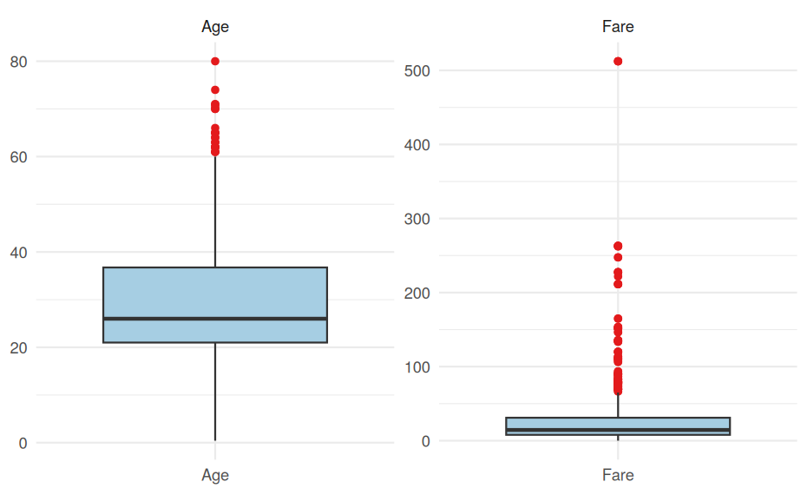
Figure 3: Boxplots of Age and Fare showing IQR-flagged outliers.
Interpretation and decision.
- Age: the 22 flagged values are all above the upper bound of about 60 years. They are genuine and plausible, so they are kept.
- Fare: 116 fares are flagged, and three exceed 500. The high fares are real first-class tickets, so deleting them would remove exactly the passengers who differ most by class. However, the skew would dominate any distance-based or correlation analysis. The better treatment is a log transform rather than removal.
- Fifteen passengers have a fare of exactly 0. These could be crew, staff or data errors; they are flagged but retained since the true cause cannot be verified.
df$Fare_log <- log1p(df$Fare)
df %>%
select(Fare, Fare_log) %>%
pivot_longer(everything(), names_to = "version", values_to = "value") %>%
ggplot(aes(value)) +
geom_histogram(bins = 30, fill = "#2c7fb8", colour = "white") +
facet_wrap(~version, scales = "free") +
labs(x = NULL, y = "Count")
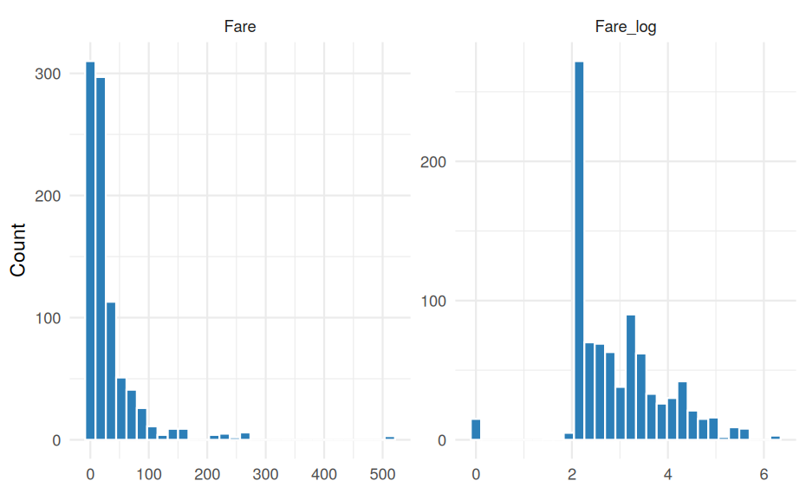
Figure 4: Fare distribution before and after a log(1 + x) transformation.
skewness <- function(x) mean((x - mean(x))^3) / sd(x)^3
c(skew_Fare = skewness(df$Fare), skew_Fare_log = skewness(df$Fare_log))
#> skew_Fare skew_Fare_log
#> 4.7712097 0.3935993
The log transform reduces the skewness dramatically, so the outliers no longer dominate the scale.

3.7 Normalisation
Two common scalings are applied, so that numeric variables on different scales (Age: 0 to 80, Fare_log: 0 to 6.2) become comparable. This matters for distance-based methods (k-NN, clustering) and for regularised models.
min_max <- function(x) (x - min(x)) / (max(x) - min(x))
df$Age_minmax <- min_max(df$Age)
df$Fare_log_minmax <- min_max(df$Fare_log)
df$Age_z <- as.numeric(scale(df$Age))
df$Fare_log_z <- as.numeric(scale(df$Fare_log))
df %>%
select(Age, Age_minmax, Age_z, Fare_log, Fare_log_minmax, Fare_log_z) %>%
summary()
#> Age Age_minmax Age_z Fare_log
#> Min. : 0.42 Min. :0.0000 Min. :-2.1285 Min. :0.000
#> 1st Qu.:21.00 1st Qu.:0.2586 1st Qu.:-0.6030 1st Qu.:2.187
#> Median :26.00 Median :0.3214 Median :-0.2324 Median :2.738
#> Mean :29.14 Mean :0.3608 Mean : 0.0000 Mean :2.962
#> 3rd Qu.:36.75 3rd Qu.:0.4565 3rd Qu.: 0.5644 3rd Qu.:3.466
#> Max. :80.00 Max. :1.0000 Max. : 3.7703 Max. :6.241
#> Fare_log_minmax Fare_log_z
#> Min. :0.0000 Min. :-3.0569
#> 1st Qu.:0.3505 1st Qu.:-0.7998
#> Median :0.4387 Median :-0.2315
#> Mean :0.4746 Mean : 0.0000
#> 3rd Qu.:0.5553 3rd Qu.: 0.5196
#> Max. :1.0000 Max. : 3.3834
Min-max values lie in [0, 1]; z-scores have mean 0 and standard deviation 1. The original columns are kept alongside the scaled ones, because the raw units are used for interpretation in the EDA while the scaled versions are reserved for modelling.

3.8 Encoding categorical variables
# Binary encoding
df$Sex_male <- as.integer(df$Sex == "male")
# Ordinal encoding (class has a natural order)
df$Pclass_num <- as.integer(df$Pclass)
# One-hot encoding for nominal variables with no order
onehot <- model.matrix(~ Embarked + Title - 1, data = df)
onehot <- as.data.frame(onehot)
df_encoded <- cbind(
df %>% select(PassengerId, Survived, Pclass_num, Sex_male, Age_z, Fare_log_z,
SibSp, Parch, FamilySize, HasCabin),
onehot
)
dim(df_encoded)
#> [1] 891 17
head(df_encoded, 4)
#> PassengerId Survived Pclass_num Sex_male Age_z Fare_log_z SibSp Parch
#> 1 1 No 3 1 -0.5289077 -0.8792467 1 0
#> 2 2 Yes 1 0 0.6570783 1.3604558 1 0
#> 3 3 Yes 3 0 -0.2324112 -0.7980917 0 0
#> 4 4 Yes 1 0 0.4347060 1.0614419 1 0
#> FamilySize HasCabin EmbarkedC EmbarkedQ EmbarkedS TitleMiss TitleMr TitleMrs
#> 1 2 0 0 0 1 0 1 0
#> 2 2 1 1 0 0 0 0 1
#> 3 1 0 0 0 1 1 0 0
#> 4 2 1 0 0 1 0 0 1
#> TitleRare
#> 1 0
#> 2 0
#> 3 0
#> 4 0
Choice of method: Sex is binary, so a single 0/1 column is enough. Pclass is ordinal, so integer coding preserves its ranking. Embarked and Title are nominal, so one-hot encoding avoids implying a false order. (For a regression model, one dummy column per variable would be dropped as a reference category to avoid perfect collinearity.)

3.9 Saving the cleaned dataset
write.csv(df, "titanic_clean.csv", row.names = FALSE)
write.csv(df_encoded, "titanic_encoded.csv", row.names = FALSE)
c(clean_rows = nrow(df), clean_cols = ncol(df), missing = sum(is.na(df)))
#> clean_rows clean_cols missing
#> 891 22 0

4. Exploratory Data Analysis

4.1 Descriptive statistics
df %>%
summarise(across(c(Age, SibSp, Parch, Fare, FamilySize),
list(mean = mean, median = median, sd = sd,
min = min, max = max),
.names = "{.col}__{.fn}")) %>%
pivot_longer(everything(), names_to = c("variable", "stat"),
names_sep = "__") %>%
pivot_wider(names_from = stat, values_from = value) %>%
mutate(across(where(is.numeric), ~ round(.x, 2)))
#> # A tibble: 5 x 6
#> variable mean median sd min max
#> <chr> <dbl> <dbl> <dbl> <dbl> <dbl>
#> 1 Age 29.1 26 13.5 0.42 80
#> 2 SibSp 0.52 0 1.1 0 8
#> 3 Parch 0.38 0 0.81 0 6
#> 4 Fare 32.2 14.4 49.7 0 512.
#> 5 FamilySize 1.9 1 1.61 1 11
lapply(df[, c("Survived", "Pclass", "Sex", "Embarked", "Title")],
function(x) round(100 * prop.table(table(x)), 1))
#> $Survived
#> x
#> No Yes
#> 61.6 38.4
#>
#> $Pclass
#> x
#> 1 2 3
#> 24.2 20.7 55.1
#>
#> $Sex
#> x
#> female male
#> 35.2 64.8
#>
#> $Embarked
#> x
#> C Q S
#> 18.9 8.6 72.5
#>
#> $Title
#> x
#> Master Miss Mr Mrs Rare
#> 4.5 20.8 58.0 14.1 2.6
About 38% of passengers survived, 55% travelled third class, 65% were male, and 72.5% embarked at Southampton.

4.2 Survival by key categorical variables
df %>%
group_by(Sex, Pclass) %>%
summarise(rate = mean(Survived == "Yes"), n = n(), .groups = "drop") %>%
ggplot(aes(Pclass, rate, fill = Sex)) +
geom_col(position = "dodge") +
geom_text(aes(label = scales::percent(rate, accuracy = 1)),
position = position_dodge(width = 0.9), vjust = -0.4, size = 3.3) +
scale_y_continuous(labels = scales::percent, limits = c(0, 1.05)) +
scale_fill_manual(values = c("#e78ac3", "#66c2a5")) +
labs(x = "Passenger class", y = "Survival rate")
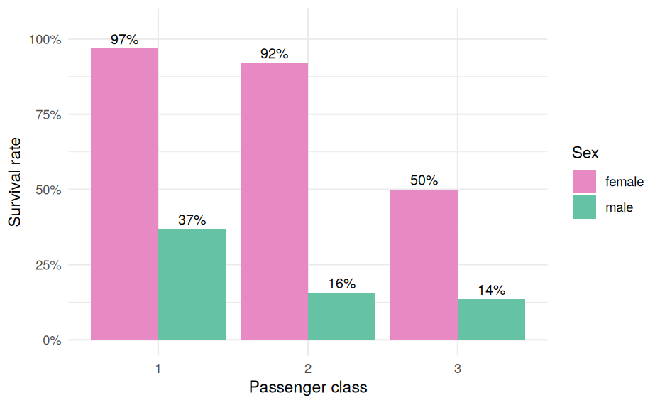
Figure 5: Survival rate by sex and passenger class.
# Survival rate (%) by sex, and by sex within class
round(100 * tapply(df$Survived == "Yes", df$Sex, mean), 1)
#> female male
#> 74.2 18.9
round(100 * tapply(df$Survived == "Yes", list(df$Sex, df$Pclass), mean), 1)
#> 1 2 3
#> female 96.8 92.1 50.0
#> male 36.9 15.7 13.5
chisq.test(table(df$Sex, df$Survived))
#>
#> Pearson's Chi-squared test with Yates' continuity correction
#>
#> data: table(df$Sex, df$Survived)
#> X-squared = 260.72, df = 1, p-value < 2.2e-16
Sex and survival are strongly associated (p-value far below 0.001). Women survived at 74.2% versus 18.9% for men, and the gap persists within every class (for example 96.8% vs 36.9% in first class, and 50.0% vs 13.5% in third class).

4.3 Survival by age
ggplot(df, aes(Age, fill = Survived)) +
geom_histogram(binwidth = 5, position = "identity", alpha = 0.6, colour = "white") +
scale_fill_manual(values = c("#fc8d62", "#66c2a5")) +
labs(y = "Count")
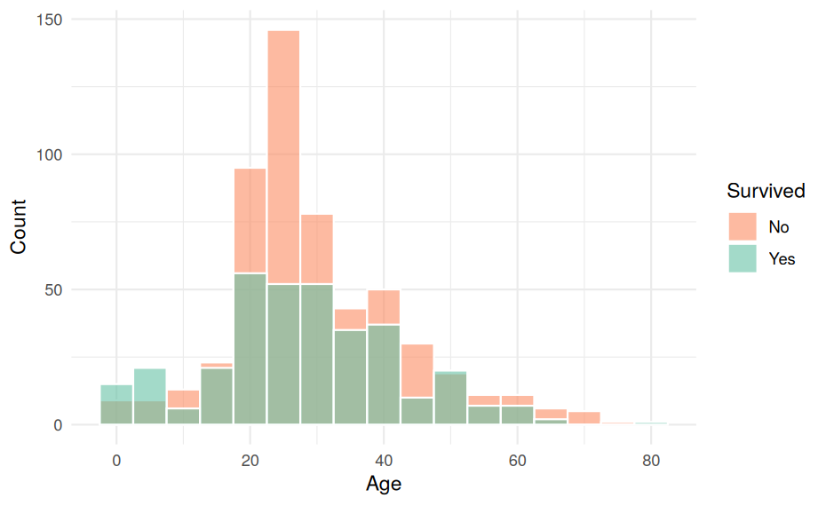
Figure 6: Age distribution by survival outcome.
df$AgeBand <- cut(df$Age, breaks = c(0, 10, 20, 30, 40, 50, 60, 100),
right = FALSE)
tab <- data.frame(
age_band = levels(df$AgeBand),
n = as.vector(table(df$AgeBand)),
survival_pct = round(100 * tapply(df$Survived == "Yes", df$AgeBand, mean), 1)
)
tab
#> age_band n survival_pct
#> [0,10) [0,10) 66 60.6
#> [10,20) [10,20) 135 44.4
#> [20,30) [20,30) 312 27.6
#> [30,40) [30,40) 186 44.1
#> [40,50) [40,50) 118 39.8
#> [50,60) [50,60) 48 41.7
#> [60,100) [60,100) 26 26.9
Children under 10 had the highest survival rate (about 61%, n = 66). Survival was lowest for passengers in their 20s (about 28%, n = 312) and for those aged 60 and over (about 27%, n = 26, a small group). Between ages 10 and 60 the rates sit in a fairly narrow 40 to 44% band apart from the dip in the 20s, so age is informative mainly at the extremes and in the 20s.

4.4 Fare and family size
ggplot(df, aes(Pclass, Fare + 1, fill = Pclass)) +
geom_boxplot(show.legend = FALSE) +
scale_y_log10() +
scale_fill_brewer(palette = "Blues") +
labs(x = "Passenger class", y = "Fare (log10 scale)")
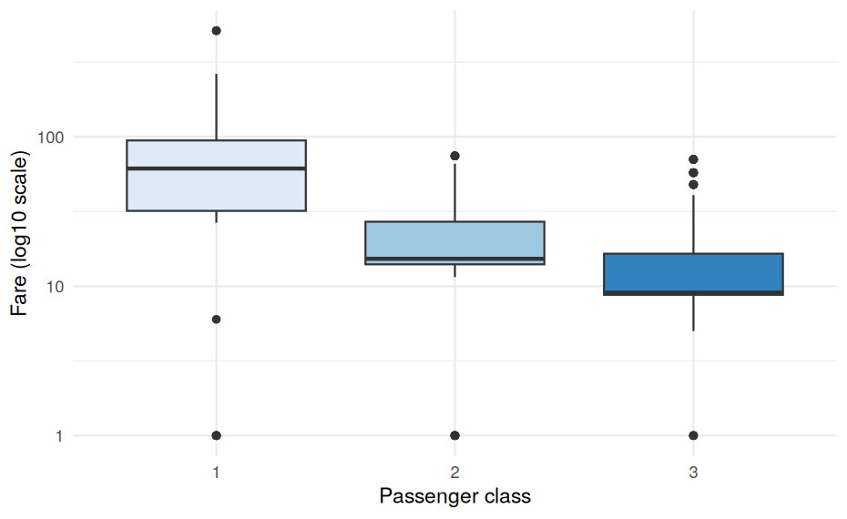
Figure 7: Fare (log scale) by passenger class.
df %>%
group_by(FamilySize) %>%
summarise(rate = mean(Survived == "Yes"), n = n(), .groups = "drop") %>%
ggplot(aes(factor(FamilySize), rate)) +
geom_col(fill = "#2c7fb8") +
geom_text(aes(label = paste0("n=", n)), vjust = -0.4, size = 3) +
scale_y_continuous(labels = scales::percent, limits = c(0, 1)) +
labs(x = "Family size (incl. self)", y = "Survival rate")
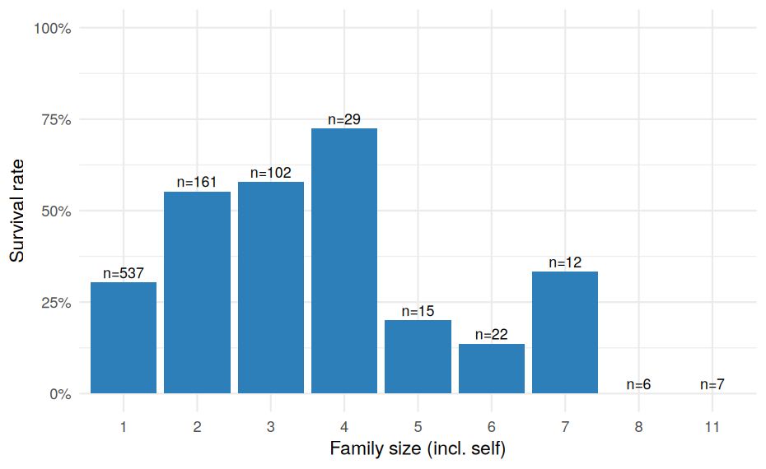
Figure 8: Survival rate by family size.
Passengers travelling alone and those in very large families (5 or more) fared worse than those in small families of 2 to 4. Note the small sample sizes (n) at the large-family end, which makes those bars unreliable.

4.5 Correlation analysis
num <- df_encoded %>%
mutate(Survived = as.integer(Survived == "Yes")) %>%
select(Survived, Pclass_num, Sex_male, Age_z, Fare_log_z, SibSp, Parch,
FamilySize, HasCabin)
cm <- cor(num)
round(cm[, "Survived"], 3)
#> Survived Pclass_num Sex_male Age_z Fare_log_z SibSp Parch
#> 1.000 -0.338 -0.543 -0.063 0.330 -0.035 0.082
#> FamilySize HasCabin
#> 0.017 0.317
# Pairs referred to in the commentary below
round(c(Pclass_vs_FareLog = cm["Pclass_num", "Fare_log_z"],
FamilySize_vs_SibSp = cm["FamilySize", "SibSp"],
FamilySize_vs_Parch = cm["FamilySize", "Parch"]), 3)
#> Pclass_vs_FareLog FamilySize_vs_SibSp FamilySize_vs_Parch
#> -0.661 0.891 0.783
# Is HasCabin just a proxy for first class?
round(100 * prop.table(table(HasCabin = df$HasCabin, Class = df$Pclass), 2), 1)
#> Class
#> HasCabin 1 2 3
#> 0 18.5 91.3 97.6
#> 1 81.5 8.7 2.4
corrplot(cm, method = "color", type = "upper", tl.col = "black", tl.cex = 0.8,
addCoef.col = "black", number.cex = 0.65, diag = FALSE)
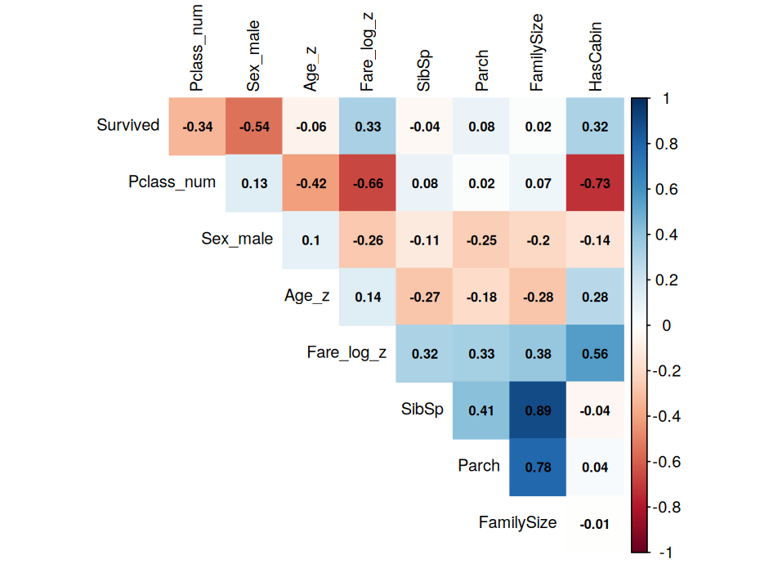
Figure 9: Correlation matrix of numeric and encoded variables.
Key correlations. Survival is most strongly related to Sex_male (strongly negative), then Pclass_num (negative: higher class number means lower survival), Fare_log_z and HasCabin (positive). Pclass_num and Fare_log_z are also correlated with each other (r = -0.66), so they carry overlapping information and including both in a model introduces some multicollinearity. FamilySize is built from SibSp and Parch (their sum plus one), so it is strongly correlated with both (r = 0.89 and 0.78) and adds little independent information beyond them. HasCabin is largely a proxy for first class: 81.5% of first-class passengers have a recorded cabin versus 2.4% in third class.

5. Summary of Insights
- Sex was the strongest correlate of survival, followed by passenger class. Women and first-class passengers had far higher survival rates.
- Class and sex interact: women in third class (50.0%) survived at a higher rate than men in first class (36.9%), so the two effects are not simply additive.
- Age matters mainly at the extremes: children under 10 had the best odds (about 61%), and passengers in their 20s and those over 60 the worst (about 27 to 28%); ages 10 to 60 outside the 20s are fairly similar.
- Family size has a non-linear effect: small families did best; solo travellers and very large families did worse.
- Fare is heavily right-skewed and redundant with class; the log transform is needed for any analysis that assumes roughly symmetric inputs.
- Missingness itself was informative: whether a cabin was recorded (HasCabin) was positively correlated with survival, largely because it proxies for first-class travel.

6. Limitations and Next Steps
- Imputation uncertainty. Median imputation understates the true variability of Age. A more rigorous follow-up would use multiple imputation (for example, the mice package) and compare results.
- Correlation is not causation. Correlations here are descriptive. Class, fare, cabin and sex are entangled, and the dataset cannot separate them causally.
- Outlier decisions rest on judgement. Retaining the zero-fare and very-high-fare records was a deliberate choice; a sensitivity analysis excluding them would test whether results change.
- Possible next steps: fit a logistic regression with the encoded features; test interactions between sex and class; evaluate how sensitive conclusions are to the imputation method.

Appendix: Session Information
sessionInfo()
#> R version 4.3.3 (2024-02-29)
#> Platform: x86_64-pc-linux-gnu (64-bit)
#> Running under: Ubuntu 24.04.4 LTS
#>
#> Matrix products: default
#> BLAS: /usr/lib/x86_64-linux-gnu/blas/libblas.so.3.12.0
#> LAPACK: /usr/lib/x86_64-linux-gnu/lapack/liblapack.so.3.12.0
#>
#> locale:
#> [1] C
#>
#> time zone: Etc/UTC
#> tzcode source: system (glibc)
#>
#> attached base packages:
#> [1] stats graphics grDevices utils datasets methods base
#>
#> other attached packages:
#> [1] corrplot_0.92 tidyr_1.3.1 ggplot2_3.4.4 dplyr_1.1.4
#>
#> loaded via a namespace (and not attached):
#> [1] vctrs_0.6.5 cli_3.6.2 knitr_1.45 rlang_1.1.3
#> [5] xfun_0.41 highr_0.10 purrr_1.0.2 generics_0.1.3
#> [9] labeling_0.4.3 glue_1.7.0 colorspace_2.1-0 htmltools_0.5.7
#> [13] scales_1.3.0 fansi_1.0.5 rmarkdown_2.25 grid_4.3.3
#> [17] evaluate_0.23 munsell_0.5.0 tibble_3.2.1 fastmap_1.1.1
#> [21] yaml_2.3.8 lifecycle_1.0.4 compiler_4.3.3 RColorBrewer_1.1-3
#> [25] pkgconfig_2.0.3 farver_2.1.1 digest_0.6.34 R6_2.5.1
#> [29] tidyselect_1.2.0 utf8_1.2.4 pillar_1.9.0 magrittr_2.0.3
#> [33] withr_2.5.0 tools_4.3.3 gtable_0.3.4

